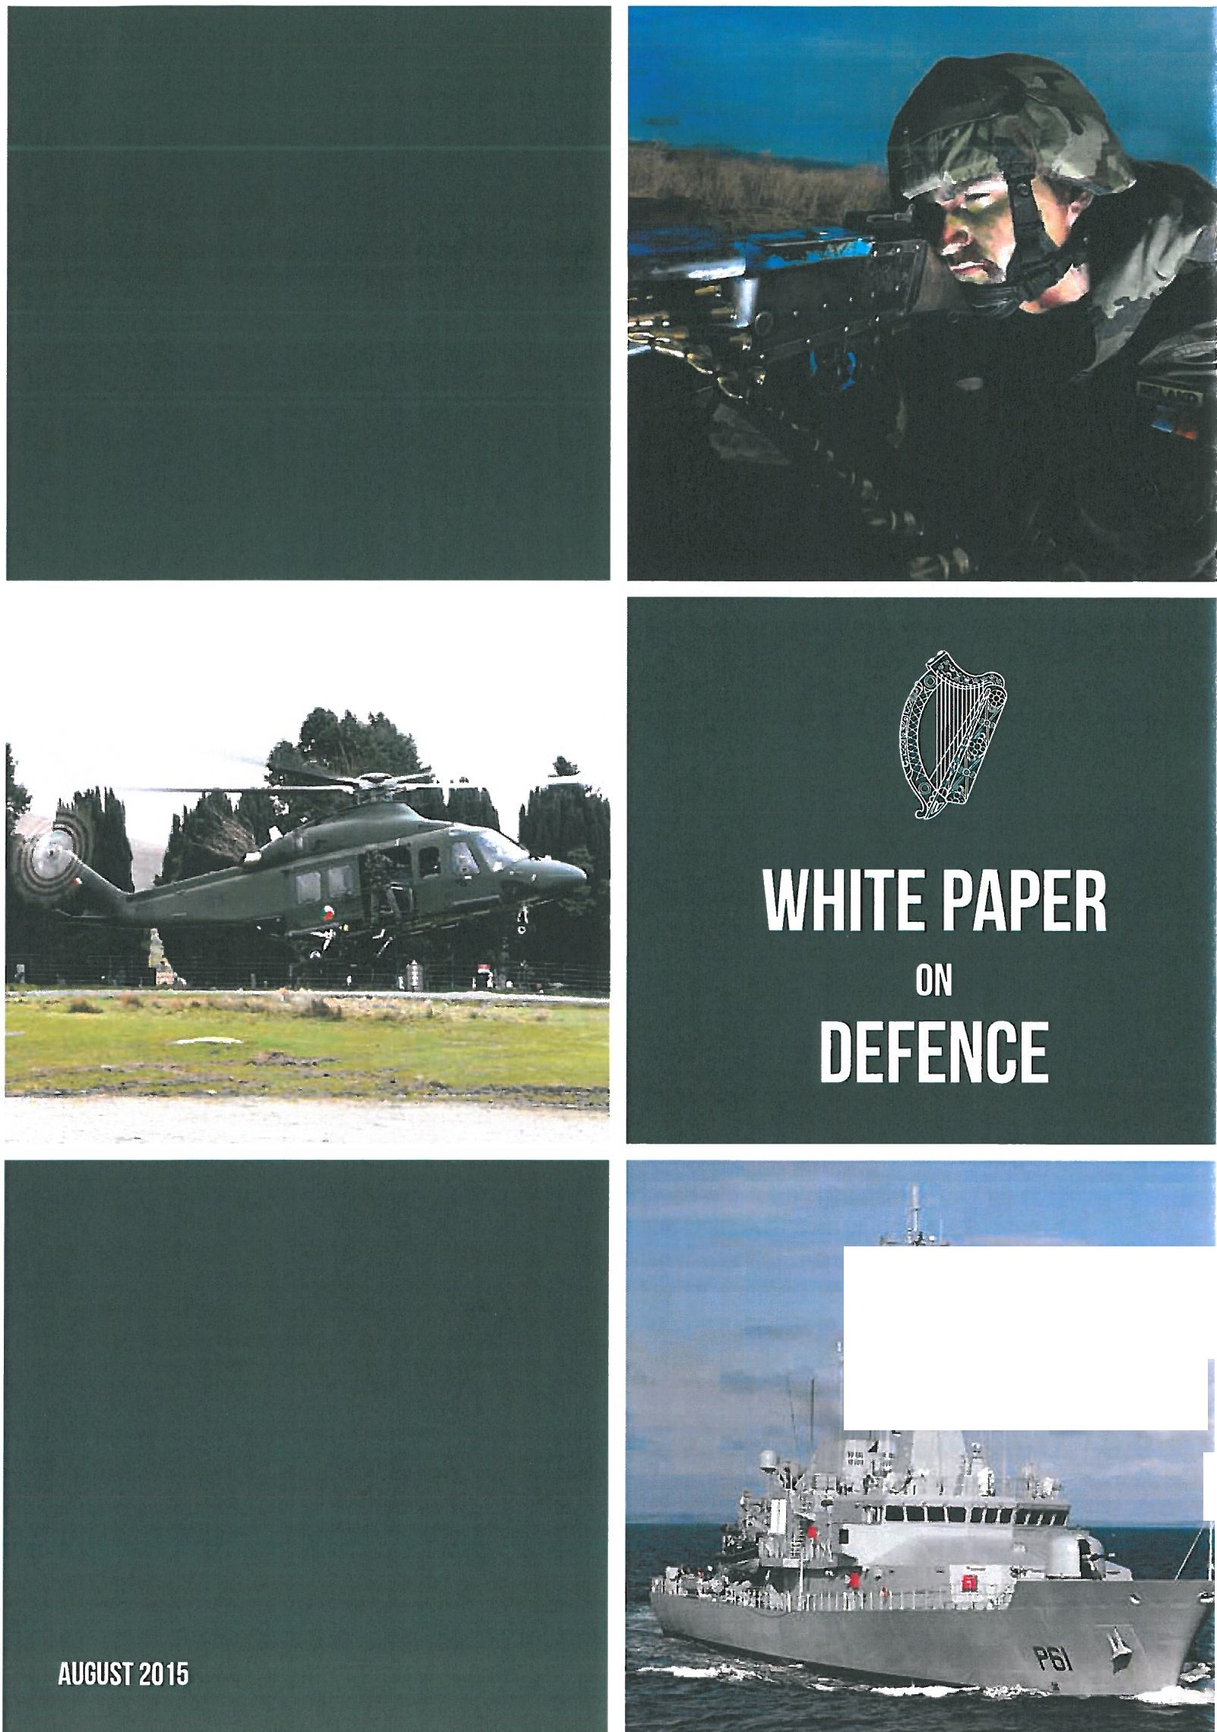

- - .., ,,l
'.'.:. l -"
..-.It
J

Policy Context
Civil Defence is a volunteer based organisation that supports the PRAs (i.e. An Garcia Sfochana, the Health Service Executive and local authorities), government departments and state agencies during national, regional and local emergency and non-emergency events.
It was originally established by Government decision in 1951, as part of the national defence structure as the necessary civil response to potential hazards which might arise in a war situation against a backdrop of the threat of nuclear war. Civil Defence has since modernised in response to changing requirements. With the ending of the Cold War in the 1990s, the focus of Civil Defence shifted towards its current tw in roles of supporting the emergency services and also providing community supports. Much of Civil Defence's activity in recent years has involved assisting at community, sporting and charity events.

Management and Organisation
Civil Defence policy is set down by the Minister for Defence through the Civil Defence Branch of the Department of Defence, based in Benamore, Roscrea, Co. Tippe rary. Civil Defence services are delivered at local level by the relevant Local Authority. The life-blood of Civil Defence is provided by some 4,000 volunteers who give freely of their time and commitment. Civil Defence services are administered by a Civil Defence Officer (COO) who is a full time employee of the local authority. The Civil Defence Branch of the Department is responsible for the strategic management and development of Civil Defence at national level. As well as grant aid, policy advice and support, the Department provides other supports to local Civil Defence units such as central training for local instructors in a " train the trainer" system through the Civil Defence College in Roscrea. The Department also supplies vehicles, uniforms and personal protective equipment for volunteers and a wide range of other equipment to local authorities for Civil Defence use.
The COO is responsible for the day-to-day management of Civil Defence matters in their local authority area. The COO acts as the link between the volunteer, com m unity, local authority and the Department nationally. The CDOs are assisted in the day-to-day management of Civil Defence training and operations by a key team of instructors, qualified in a range of disciplines. Apart from the payment of expenses for travel and subsistence, in certain circumstances, Civil Defence members make themselves available for training, exercises or operations on a voluntary basis.

Development of Civil Defence
The Government are committed to the continued development of Civil Defence. The volunteer ethos of Civil Defence is a hallmark of great pride and one which the Government wish to cherish and support into the future. The Government also recognise the important role of Local Government in the managem ent of Civil Defence and wish to support the continued role of local authorities in fostering the contribution of Civil Defonce.
103

1()-J:
The future of Civil Defence will continue to be developed around its central strategic objective of supporting the PRAs in a variety of emergency and non-emergency situations. This embraces the large number of support roles under the Framew ork for Major Emergency Management (MEM) including assistance in dealing with a wide range of emergencies at national and local level, including severe weather, flooding and searches for missing persons. All of the foregoing are referred to as core services.
The Civil Defence Act 2012, provides statutory underpinning to the preparation of local Civil Defence Plans. These provide the means for each local author ity, under the policy oversight of the Minister for Defence, to have a strong local plan consistent with local needs. A feature of Civil Defence in recent years has been the development of more regionally based approaches built around inter-local authority co-operation. This regional approach will be developed further to capitalise on the strengths and capacities in different local authority areas.
The principal legislation governing Civil Defence dates back to 1939. While there has been some amending legislation over the years, there is a need to provide a more modern aggregated piece of governing legislation. New legislation will be progressed in this regard over the life-time of the White Paper.
In order to enhance liaison under the MEM and guide the continued development of Civil Defence in response to evolving requirements, the Government propose to establish a new Inter-agency Guidance Team (IGT) led by the D epa rtm ent of Defence (Civil Defence Branch) and otherwise comprising representation from the National Directorate for Fireand Emergency Management in the Department of the Environment, Community and Local Government, An Garcia Sfochana, the Defence Forces, the HSE and local authorities through the participation of the County and City Management Association and the Civil Defence Officers' Association. It is foreseen that the new IGT will help to ensure that Civil Defence services and capabilities are developed in the light of the needs of the PRAs under the MEM. It will provide additional support to national leadership from Civil Defence Branch across the entire organisation in relation to emerging standards and address issues of common concern to Civil Defence and the PRAs.
Over the years, Civil Defence volunteers have been utilised in a variety of community support roles at local level. While recognising that Civil Defence volunteers are drawn from the local community and have a long and proud history of assisting at community events, there are limits to the support that can be provided, within available resources. Where resources permit and with the agreement of the local authority, Civil Defence will continue to support appropriate community events. These events can provide an opportunity for Civil Defence volunteers to practice their skills wh ile contributing to the community. They also raise the profile of the organisation and may be useful for recruiting volunteers. However, in the continued development and support of Civil Defence, the White Paper places emergency support as the priority task of Civil Defence.
Civil Defence will continue to work closely with other volunteer-based organisations involved in emergency supports such as M ountain Rescue, the Irish Red Cross, St John's Ambulance, the Order of Malta and sub-aqua clubs.

Capabilities
Civil Defe nce derives its capabilities from its core services of Casualty, Search & Rescue, Auxiliary Fire Service, Radiation Monitoring, Welfare and Communications. Generally Civil Defence's support is a capability derived from a combination of these

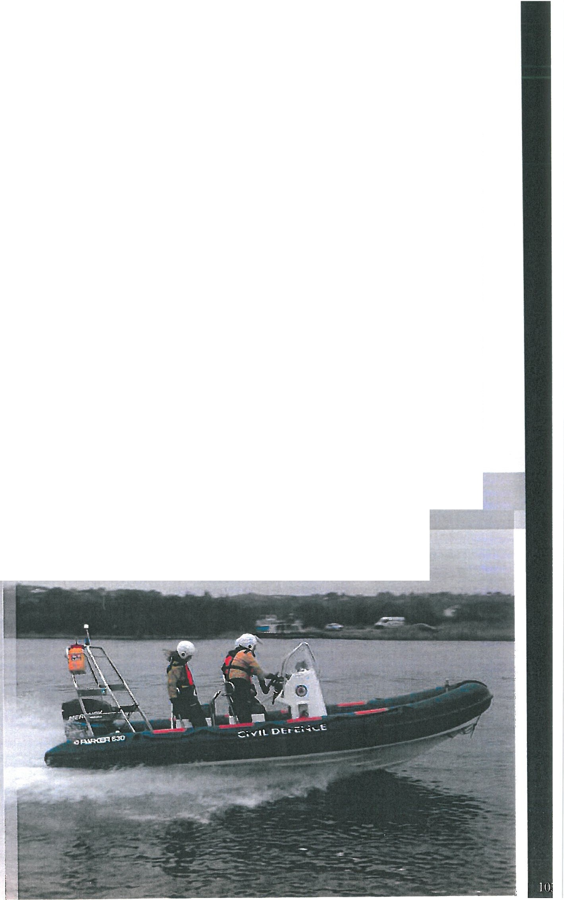services. Through the new IGT, the Department will ensure that Civil Defence core services remain relevant to changing needs at national, regional and local level and that Civil Defence remains an effective volunteer based emergency support organisation. Existing MOUs and SLAs will be reviewed and, where relevant, updated. Opportunities for further SLAs will also be explored.
The Department, through Civil Defence Branch, will communicate clearly, to all stakeholders, the Civil Defence capabilities that are available in emergency and non­ emergency response. This is to ensure that capabilities are not just developed but are promptly called upon in emergency situations.
The Government recognise the importance of the training provided at the Civil Def ence College. It is a recognised training centre of the Pre-Hospital Emergency Care Council. Civil Defence volunteers are trained to recognised national and international standards. Civil Defence will continue to develop its high quality Casualty Service.
Civil Defence will continue to develop its search and rescue capability in support of An Garcia Sfochana. This will include the expansion of its Remotely Piloted Aircraft Systems (RPAS) capability and continued joint training with An Garcia Sfochana. This service will also encompass any approved future Urban Search & Rescue capability.
Civil Defence will continue its support to local authorities, primarily their fire services, in times of severe weather including for flood response operations, the movement of water and other support roles.
A very effective feature of the work of Civil Defence's volunteers is in the supply of certain welfare services in emergency situations including the capacity to deal with displaced persons and set up feeding and rest centres. This capability will

be maintained and developed including Civil Defence's capacity to support its own operations and those of the PRAs and other agencies in the event of national, regional or local emergencies.
Civil Defence will maintain and further develop its capacity for radiation monitoring, both on a national or regional basis, to collect samples, take radiation readings and to deliver such samples/data to the Environmental Protection Agency for further analysis.
Civil Defence has a well developed radio communications system. This operates on a national, regional and local level. Civil Defence also has a range of command and control facilities which it makes available in support of the PRAs. These services w ill be maintained and further developed according to need.
The Civil Defence Branch will utilise, if feasible and where it makes sense, technical assistance from the Defence Forces in the context of avoiding replication of scarce skills within the Defence Organisation.

Personnel and Training
The Civil Defence organisation has approximately 4,000 active members listed on the Civil Defence volunteer register. This is a very significant national resource with its own unique local footprint. The Government will ensure that a strong focus will be maintained on fostering this volunteer ethos into the future.
In order to provide for the best future management and deployment of Civil Defence, the Government authorise a process through which each local auth ority under their Civil Defence Plans, in conjunction with the Department of Defence, w ill determine an appropriate volunteer strength for each of its services. These volunteers will be trained to reflect roles and priorities.
Civil Defence volunteers will continue to be trained in various skills such as casualty, search and rescue, flood response, radiation monitoring, welfare and communications. Health and safety requirements will inform approaches to training and equipment plans. The Department will maintain and develop the training programmes and skill sets within the organisation to national and international standards and best practice. The Civil Defence College will organise specific training across all core services. This training will continue to be provided to national and/or internationally accredited standards. Civil Defence will identify and make use of national synergies in training and operational capacities to make best use of financial resources and shared services including the development of further links with third level institutions.

Equipment and Infrastructure
Civil Defence will utilise new technologies that assist in delivering its core services. For example, civil Rem ote ly Piloted Aircraft Systems (RPAS) are being utilised in missing persons' searches. Civil Defence has also acquired a large number of TETRA radios allowing for efficient communications with the PRAs during emergencies.
The Department of Defence will continue to provide the resources and supports necessary to fulfil the mission of Civil Defence, including fit-for-purpose equipment, uniforms and Personal Protective Equipment. Within available funding, a programmed approach will be taken to the ongoing replacement of older equipment, including vehicles and boats, with obsolete equipment being withdrawn from service.
Responsibility for the accommodation of local Civil Defence Units will remain with the relevant local authority. Most local authorities have provided good quality

1() (5

accomm odation for their Civil D efence Units. However, the accomm odat ion of some Units could be improved. The Department will work pro-active ly with local authorities to ensure that appropriate accommodation is provided for all Civil Defence Units. The Department of Defence will continue to provide high quality infrastructure for Civil Defence at a national level, including any necessary improvem ents to the facilities of the Civil Defence College.

Funding
CivilDefence planspreparedby local authorities under the CivilDefence Act2012, require adequate resources for their im plementation in respect of national and local elem ents. Aside from strong local political and management leadership and commitment, these resources include the Personnel, Training, Equipment and Infrastructure required to enable all core services operate at the appropriate level.
Civil Defence training and operations are funded by a combination of a ce ntral Exchequer grant from the Department of Defence and a contribution from the relevant local authority. In addition to the administrative costs of the Civil Defence Branch of the Department of Defence, and central training and equipment expenditure, some €2.75m is being provided in 2015 for Civil Defence funding to local authorities. Expenditure incurred by Local Authorit ies on Civil Defence is grant-aided to the extent of 70% by the Department of Defence. The Department also supplies vehicles, uniforms and personal protective equipment for volunteers and a wide range of other equipment to local authorities for Civil Defence use. This can be supplemented by local authorities. While accommodation for local Civil Defence Units is the responsibility of the relevant local authority, the Department of Defence has provided some funding for the upgrading of accommodation where resources have permitted.
Consistent with Defence fund ing overall, the Government intend that financial allocations will be maintained in order to underpin Civil Defence development and in particular to retain necessary capabilities into the future. Additional funding will be provided for new training courses as required, updating and replacing equipment and uniforms and also for any necessary upgrading of the infrastructure at the Civil Defence College. The Department will promote synergies with other agencies to make best use of financial resources.

