Civil Defence pilot drones for searches
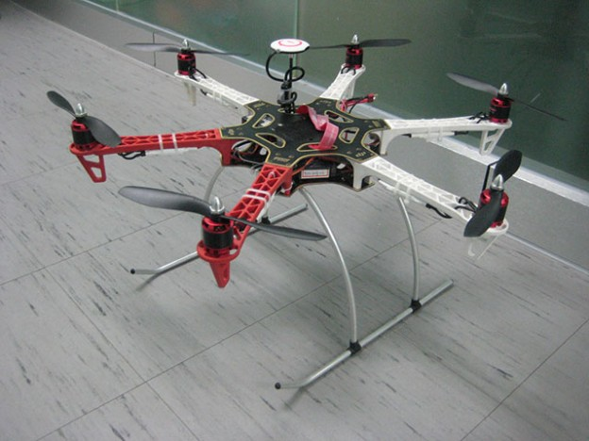
The Civil Defence have purchased two Remotely Piloted Aircraft Systems (RPAS) or as they are also known as drones, on a trial basis in order to select a type best suited to the organisation in terms of its capabilities and ease of flight operations which is hoped will assist volunteers in search operations.
A project undertaken by the Civil Defence technical and Communications Unit will research and develop the RPAS in order to take it to a working solution.
The first one is a DJI Flamewheel F550 which has a GoPro 3 camera mounted underneath on a gimbal, to provide stabilised live video imagery, to a receiver station on the ground. The live feed can be viewed on the pilot’s screen and also on a large screen monitor by an observer.
The second unit is a DJI S800 EVO with a Sony NEX7 (High Spec) camera, mounted on a three axis stabilised gimbal. This system again provides high quality imagery of the surveyed ground area to the receiver screens on the ground.
All screens display the flight information for the craft which includes altitude, vertical and horizontal velocity, distance and direction from the operator, number of GPS satellites visible, mode of operation and also the battery voltage level. All the flight data is superimposed on the video imagery coming from the camera, mounted on the craft.
All operators of Remotely Piloted Aircraft Systems must be licensed by the Irish Aviation Authority. This license consists of two parts. One is a Permission to Operate a Remotely Piloted Aircraft System and the second is an Aerial Work Permission. In order to gain the necessary permissions, potential operators must first complete an Aeronautical Ground School Course followed by a flight test conducted by an Aeronautical Inspector from the Irish Aviation Authority.
Civil Defence Technical team completed the Aeronautical Ground School Course at the National Maritime Institute, Ringaskiddy, Cork. Among the topics covered were: IAA Regulations surrounding the operation of RPAS in Ireland, Principles of Flight, Meteorology for RPAS Operators, Flight Control, Telemetry & Navigation Systems and also Human Factor Risks.
A prerequisite, prior to applying for the flight test, was the compilation of a Flight Operations Manual, outlining the methodologies and procedures employed by Civil Defence for RPAS operation. Also, a full Equipment Technical Manual, for all items of equipment in use, had also to be included. These were then submitted with the Flight Test Application.
While awaiting a date for the flight test, the flying skills of both operators continued to be improved. This entailed flying the various craft, at different locations, to gain the necessary expertise and proficiency over varying terrain and weather conditions.
The flight test was successfully completed by both the Civil Defence operators at a site in Tipperary in July 2014 and the required permissions were issued by the IAA. The service became fully operational in September 2014. The operating skills continued to be honed and experience gained during operations highlighted the limitations of the RPAS in inclement and windy weather. It also revealed that the analogue video signal being transmitted from both these Hexacopter RPAS can suffer degradation from interference.
As a result of this experience, a small versatile Quadcopter, a Phanthom 2 was acquired. This craft transmits a full HD digital signal to a HD receiver ground-station, resulting in a very clear and stable picture. Also, a large Octocopter (DJI S1000) with the same HD video digital transmission quality, via a Panasonic GH4 camera, was added to the fleet. The S1000 is an Octocopter with eight rotors that has vastly improved stability in windy conditions. The diversity of crafts, therefore, provides a wide skillset, to our operators, employing the different craft in a variety of roles.
As operational experience is gained, the next step is to establish a number of RPAS units at strategic locations around the country on a phased basis. This, of course, would be dependent on the demand for the service across the country and also how successful it is in supporting search operations.
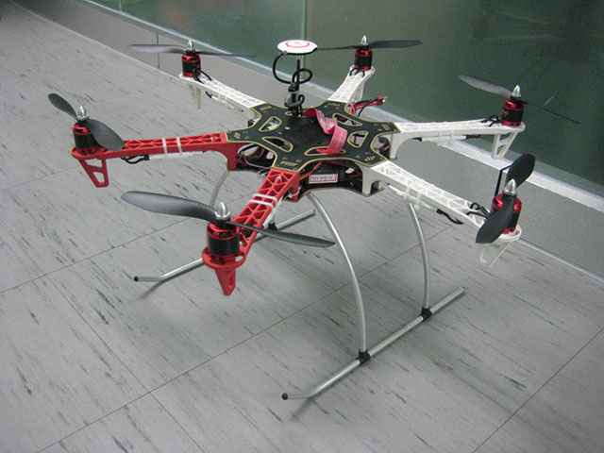
Civil Defence volunteer operators would have to go through the same training and testing regime as our current operators. They would also be responsible for the maintenance of the craft in their unit and also would be required to keep detailed records associated with the Fight Operations Manual, such as a Flight Log, Maintenance Log, and Incident Log etc.
It is envisaged that the craft type, for local operations, will be selected in due course. This will then become the standard craft within Civil Defence. The actual selection of the type will be completed after more experience is gained during flight operations. The RPAS provide a significant support resource to the Officer in Charge of operations, on the ground, but it must be remembered that such craft have limitations and must be operated safely and within the constraints laid down by the IAA.
Any potential operator selected to undergo training in RPAS operation must fully understand the technology incorporated within the complete system and ancillaries. In addition, the operator must have a full understanding of the rules and regulations as laid down by the IAA, in relation to the operation of Remotely Piloted Aircraft Systems.
This is a use of an emerging technology that neatly compliments Civil Defence capabilities, who are always looking towards new innovative systems and technologies that would expand the operational capability and effectiveness of the organisation and thereby enhance the professionalism of the volunteer organisation that we are a part.

